Procedure for the Control of
Documented Information

Security Classification: Confidential

Document Reference: ISMS07002
Version: 1.0
Draft 4

Document Author: Cybersecurity Unit

Document Owner: NCS/TMP

Revision History

Version | Date | Change Number | Summary of Changes
1.0 | 21 Nov 23 | Draft 1 | Tailoring to NCS
1.1 | 27 Nov 23 | Draft 2 | Legal Review
1.2 | 1 Dec 23 | Draft 3 | Independent Expert Review
1.3 | 11 Dec 23 | Draft 4 | Unit level signoff

Document Review

Date of Next Scheduled Review
20 November 2024

Distribution

Name | Title
Bukola Omoniyi | Officer in Charge Project management
Abubakar Sadiq | Project Management
Oliver Nnona | Independent Expert
MJ Abubakar | Officer in Charge, Cybersecurity
Maduka Emelife | Independent Expert
Uche I Egolum | NCS Legal

Approval

Name | Position | Signature | Date

Contents

1 Introduction 5
2 Document Control Process 6
2.1 Overview 6
2.2 Creation of Documents 7
2.2.1 Naming Convention 7
2.2.2 Version Control 7
2.2.3 Status 8
2.2.4 Documents of External Origin 8
2.3 Document Review 8
2.4 Document Approval 9
2.5 Communication and Distribution 10
2.6 Review and Maintenance of Documents 10
2.7 Archival of Documents 10
2.8 Disposal of Documents 10

Introduction

The ISO/IEC 27001 standard requires that all documents that make up the Information Security Management System (ISMS) must be controlled. Such control is essential to ensure that the correct processes and procedures are always in use within the Project Management Office (PMO) and that they remain appropriate for the purpose for which they were created.

The general principles are that all documented information must be:

- Readily identifiable and available.
- Dated, and authorised by the proper Officer.
- Legible and readable.
- Maintained under version control and available on a need-to-know basis.
- Promptly withdrawn when obsolete and retained in/as an archive where required for legal or knowledge preservation purposes, or both.

This procedure sets out how this level of control will be achieved within the Project Management Office (PMO).

Document Control Process

Overview

The overall process of document control is shown in the diagram below.

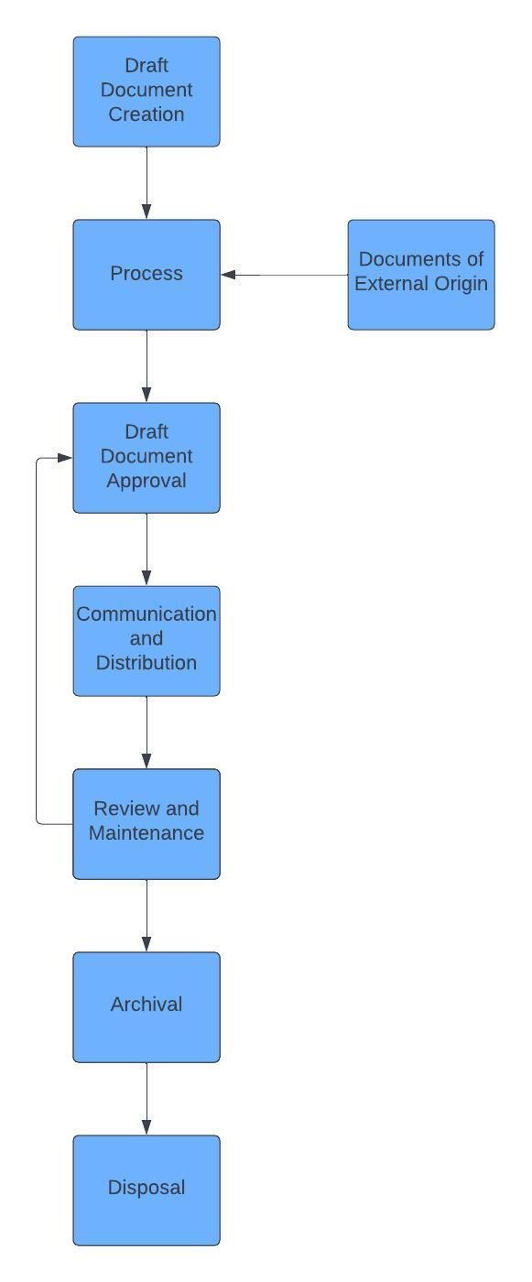

Figure 1 – Document Control Process

Each of these steps is described in more detail in the remaining sections of this document.

Creation of Documents

The creation of documents will be as required for operational purposes, appropriate to the subject and security classification of the document. The following subsections provide guidelines for creating documents within the PMO.

ISMS Document Naming Convention

ISMSxxxxx Document Title V1R0 Draft x

Where ISMS = Information Security Management System
xxxxx = 5 digit unique document number
Document Title = Meaningful description
V1R0 = Version 1 Release 0
Draft = status of document
X = Number of draft

A 5-digit unique number will be allocated for each document and an index of references maintained within the ISMS Quality System. See ISMS07001 Information Security Management System Documentation Log for more details.

No fixed format is prescribed for records and logs as these will often be determined by other systems and software. Where possible the name of a log or record should be self-explanatory and meaningful in the context of its use. See ISMS07003 Procedure for the Control of Records for more detail.

General Naming Convention

Ref: NCS_PMO_Unit_D_S_ddmmyy
XXX = 3-digit unique file number
X = File volume number
Document Title = Meaningful description
Security Classification = Restricted, Confidential, Secret, Top Secret
Draft = status of document

Version Control

Document version numbers will consist of a major and a minor number e.g. 2.1 is Version 2 Release 1.

When a document is created for the first time it will have a version number of 1.0 and be in a status of Draft. Each time a draft is distributed, any further changes will result in the draft number being incremented by 1 e.g., from 1 to 2

For example, when a document is first created it will be Version 1.0 Draft 1. A second draft will be V1.0 Draft 2 etc. When the document is approved it will become V1.0 Final.

The major number will be incremented when a subsequent version is published and when significant changes have been made. The minor number will be incremented when small changes have been made.

For example, a major revision of an approved document which is at V1.0 Final will be V2.0 Draft 1 then V2.0 Draft 2 etc. until approved when it will become V2.0 Final.

The document must include a revision history as follows:

Revision History

Version | Date | Change Number | Summary of Changes

Once the document reaches its final version, only approved versions should be recorded in this table.

Status

The status reflects the stage that the document is at as follows:

Draft = Document under development and discussion i.e., it has not been approved.

Final = Following acceptance at approval board and released into live work environment

Documents of External Origin

Documents that originate outside of the PMO, but form part of the ISMS will be allocated a reference and a header page attached at the front of the document, setting out information that is normally included in internal documents i.e.:

- Document reference.
- Version
- Status
- Distribution
- Storage location

Such documents will then be subject to the same controls as those that originate internally.

Document Review

Draft documents will be reviewed by designated Officers appropriate to the document content, security classification, and subject.

Guidelines are as follows:

Document Type | Reviewers
Strategy
Policy
Procedure
Plan

Scheduled review information should be recorded as follows:

Date of Next Scheduled Review

Once approved, the date of next scheduled review should also be recorded in ISMS07001 Information Security Management System Documentation Log.

Document Approval

All documentation must go through the Management to ensure that it is correct, fit for purpose and produced within Service documentation control guidelines. The Management will differ dependent upon the type of documentation and may require technical/expert opinion from appropriate units prior to being approved as a Final document.

In standard terms, approving bodies are:

Document Type | Approvers
Strategy | Management
Policy | Management
Procedure | ACG (ICT-MOD)
Plan | ACG (ICT-MOD)

Each document that requires approval should have a table for the purpose as shown below:

Approval

Name | Position | Signature | Date

Once approved, a copy of the document must be printed and signed by the approver. This copy will then be securely retained.

Upon approval of a new version of a document, all holders of previous versions will be instructed to obtain the new version.

Communication and Distribution

A distribution list will be included as follows:

Distribution

Name | Title

This list must be accurate as it will be used as the basis for informing users of the document that a new version is now available.

Review and Maintenance of Documents

All final documents must be stored electronically and in paper format to ensure that they are accessible in any given situation.

Final documents are stored in paper format in a filing structure that mimics the electronic version.

Archival of Documents

Approved documents exceeding their useful life should be archived for a stipulated number of years (10 years) as prescribed by the Nigeria Customs Service Act of 2023.

Disposal of Documents

Paper copies of approved documents that have been superseded are to be shredded.

